ONEWAY CS BY DAW
/STATISTICS DESCRIPTIVES HOMOGENEITY WELCH
/PLOT MEANS
/MISSING ANALYSIS.

Oneway

Notes
Output Created |  | 05-May-2019 23:26:03
Comments
Input | Active Dataset | DataSet0
Input | Filter | <none>
Input | Weight | <none>
Input | Split File | <none>
Input | N of Rows in Working Data File | 30
Missing Value Handling | Definition of Missing | User-defined missing values are treated as missing.
Missing Value Handling | Cases Used | Statistics for each analysis are based on cases with no missing data for any variable in the analysis.
Syntax |  | ONEWAY CS BY DAW  /STATISTICS DESCRIPTIVES HOMOGENEITY WELCH  /PLOT MEANS  /MISSING ANALYSIS.
Resources | Processor Time | 00 00:00:00.156
Resources | Elapsed Time | 00 00:00:00.157

[DataSet0]

Descriptives
 | N | Mean | Std. Deviation | Std. Error | 95% Confidence Interval for Mean
 |  |  |  |  | Lower Bound | Upper Bound
1-3 days a week | 12 | 36.0000 | 3.64318 | 1.05169 | 33.6852 | 38.3148
3-5 days a week | 5 | 40.0000 | .00000 | .00000 | 40.0000 | 40.0000
5-7 days a week | 13 | 40.0000 | .00000 | .00000 | 40.0000 | 40.0000
Total | 30 | 38.4000 | 3.00115 | .54793 | 37.2794 | 39.5206

Descriptives
 | Minimum | Maximum
1-3 days a week | 28.00 | 40.00
3-5 days a week | 40.00 | 40.00
5-7 days a week | 40.00 | 40.00
Total | 28.00 | 40.00

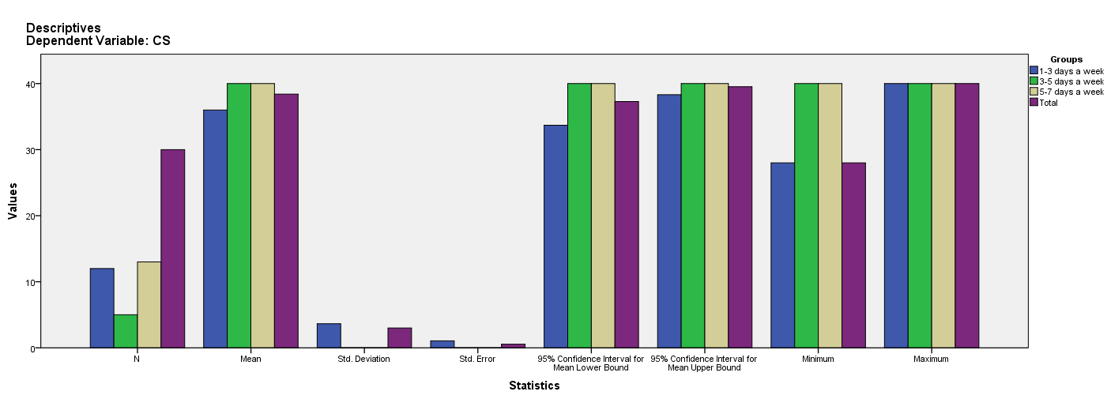

Test of Homogeneity of Variances
CS
Levene Statistic | df1 | df2 | Sig.
11.393 | 2 | 27 | .000

ANOVA
CS
 | Sum of Squares | df | Mean Square | F | Sig.
Between Groups | 115.200 | 2 | 57.600 | 10.652 | .000
Within Groups | 146.000 | 27 | 5.407
Total | 261.200 | 29

Robust Tests of Equality of Means^{b}
CS
 | Statisticª | df1 | df2 | Sig.
Welch | . | . | . | .
a. Asymptotically F distributed.
b. Robust tests of equality of means cannot be performed for CS because at least one group has 0 variance.

Means Plots

